Vice-President Report: Annual General Meeting  
Academic Year 2024/2025

As Vice-President of the Students' Union, it’s been an incredibly rewarding year of growth, learning, and building stronger connections with students. In this report, I will outline the key areas of work I’ve focused on this academic year, highlighting the initiatives I’ve driven, the collaborations I’ve nurtured, and the opportunities I’ve created for students to engage, grow, and thrive. This report isn’t extensive, so please feel free to ask me questions about anything not included here, or if you’d like more information about anything in particular.

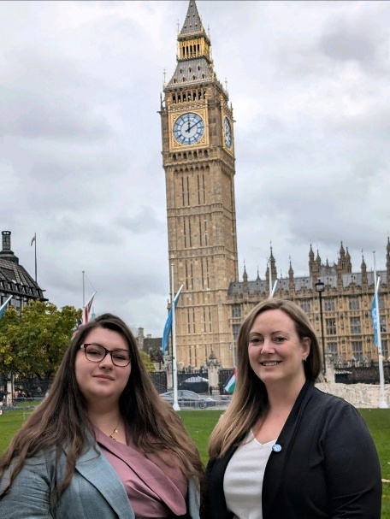

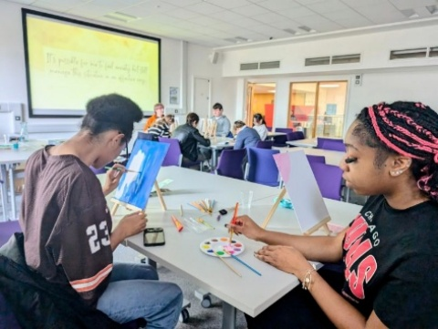

# Building a Welcoming and Supportive Environment

One of my core priorities this year has been to help shape the Students’ Union into a space where students feel welcome, supported, and part of a community. Throughout the year, I’ve worked hard to foster this atmosphere of inclusivity and belonging, whether that be through initiatives to support student wellbeing, create spaces for student development, or encourage students to take an active role in their university life.

On my very first day I got in early, and started moving the furniture about. I’m grateful that our Union Director and SU President both shared in this vision for the space, to create an open and inviting recreational style area at the front facing part of the offices. I feel like this has been an important element involving inviting students into the space, and I’m really please to have seen so many students using the space over the year for recreation, socialisation and relaxation.

In collaboration with the SU President, I helped to establish Cuppa & Chat a simple but impactful initiative where students can come and have free hot drinks and biscuits, all while having the chance to chat with us about anything on their mind. This initiative stemmed from both of our manifestos (Although I think Gemma’s name choice of Cuppa & Chat was more punchy than my Tea & Chat) and has been a great way to engage with students in a relaxed and informal setting. Whether students wanted to discuss ideas, air grievances, or simply take a moment to relax, Cuppa & Chat created a space for all voices to be heard.

In a similar vein, I’ve partnered with the Academic Affairs Officer to launch the Newman Students' Union Study Group, a body doubling initiative where students can gather in a shared space, offering a supportive environment to stay motivated and study together. By providing free fruit and drinks, we’ve aimed to encourage healthy habits while also fostering a sense of community among students who may not have otherwise interacted. A key bit of feedback from this was that the space offered time and motivation to get things done students had been putting off: bits of planning, bookings appointments with careers for ASAs. Students have been able to achieve a lot in the space including getting started, finalising and even submitting assignments, so I’m super happy with how this has panned out and hope we can continue this into the new year, perhaps with some expansion.

# Wellbeing Focus: A Year of Growth, Reflection, and Connection

Supporting student wellbeing has been at the heart of much of my work this year. It’s been about creating spaces, events, and resources that allow students to prioritise their mental and emotional health while also offering them opportunities to grow in a variety of ways.

Wellbeing Week was a standout initiative this year. The week-long event, led primarily by students, centred on how students can actively support their own wellbeing while balancing academic life. The activities were designed not only to support mental health but also to help students develop valuable life skills. Highlights included guided and unguided mindfulness sessions, a sensory first-aid workshop, painting for radical acceptance, and a roundtable on self-care. These activities offered students a chance to reflect on their wellbeing, learn new techniques for managing stress, and express themselves creatively in a low-pressure environment.

The event was particularly successful in attracting a diverse mix of students, including those who had never attended an SU event before. The painting for radical acceptance session ‘Painting Party’, in particular, proved to be extremely popular, with many students enjoying the freedom to express themselves creatively without judgment. This event, like the others, was not only valuable for the students who participated, but also for those leading the activities. It provided an opportunity for them to develop their presenting, teaching, and group-leading skills, which I hope will serve them well in the future.

The success of Wellbeing Week has set a precedent for what we can achieve when students take the lead in organising and running wellbeing initiatives. Moving forward, I hope to see this initiative grow into an even bigger and more ambitious project. My vision for Wellbeing Week is to develop it into a coordinated, annual conference that brings together students, the SU, the University and also external speakers & interested individuals to share knowledge and resources in a meaningful way. This would help establish a long-term focus on student mental health and holistic wellbeing at Newman.

# Launch Something New: Opportunities for Student Development

One of my key initiatives this year was the creation and development of Launch Something New, an initiative designed to make it easier for students to start their own societies, events or initiatives. This initiative seems to have been successful in encouraging students to take ownership of their university experience by creating the spaces they want to be a part of.

The success of Launch Something New has been a significant factor in the growth of the SU this year, with the number of active societies increasing from 7 to 15. This means we have more societies which have been started this academic year, than societies which have continued to operate from the previous year. This growth has been driven by students who are empowered to create something that reflects their interests and passions. I am incredibly proud of this outcome, and it’s a clear indication that students at Newman are eager to get involved and make their mark.

Looking ahead, I’m excited to make Launch Something New even more accessible to students next year. I’m currently working on a survey to gather feedback from society committees, which will help refine the process and make it easier for students to get their ideas off the ground. This will ensure that the SU continues to be a space where students feel supported in taking initiative and building the communities they want to see.

# Opportunities for Growth and Collaboration

In addition to supporting student wellbeing and society development, I have also focused on creating opportunities for students to engage with different aspects of university life and gain valuable skills. This year, I’ve worked closely with several departments across the University to ensure we can offer meaningful opportunities to engage in the wider community in a way which is development focused.

In collaboration with the University’s Environmental Advisor, we successfully ran Green Week, which not only provided students with information about sustainability but also showcased their entrepreneurial ideas through the Eco-Business Fair, and more student-led activities like Outdoor Art’s seed paper making workshop. This event allowed students to engage with sustainability from a practical, entrepreneurial, and lifestyle sustaining perspective, and I’m hopeful that this will continue to grow. The partnership with the University has also created lasting relationships that I believe will lead to even more student involvement in eco-friendly initiatives, such as the Greenhouse Project. I’m also excited about the possibility of offering HEAR accreditation for student involvement in sustainability initiatives like Greenhouse project, which is hopefully in the works for next academic year. This would give students recognition for their participation in projects that benefit the wider community and the environment.

# Looking Forward: The Union’s Growth and Our Future

As I reflect on the progress we’ve made this year, I’m incredibly proud of what we’ve achieved together. I believe we’ve successfully worked toward realising the vision set out in the Union’s strategy, and we’re headed in a positive direction. The relationship-building efforts I’ve made with university departments have had a real and tangible impact on student life, from wellbeing initiatives to sustainability efforts.

I’m excited about the future and the opportunities that lie ahead. As we look to next year, I’m confident that the foundation we’ve built this year will lead to even greater success. I’m particularly excited about expanding our student-led wellbeing initiatives and continuing to make the SU a place where students feel they truly belong.

To briefly conclude, this year has been a year of growth, collaboration, and building stronger connections with students and departments across the University. From wellbeing initiatives like Wellbeing Week to creating more opportunities for student involvement with Launch Something New, we’ve worked hard to create a space where students can thrive. I’m excited for what the next academic year will bring and am looking forward to continuing our journey of growth, support, and opportunity for all students at Newman.